 | 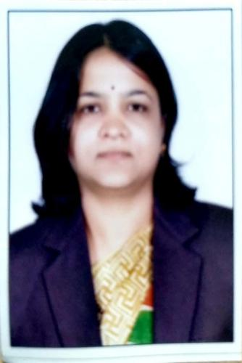 | Name of Faculty:  Mrs. Shubhada.M. seikdar  Assistant Professor  Department of Science & Humanities
1. | Name in Full | Mrs. Shubhada Mukund Seikdar
2. | Mother’s Name | Mrs. Vanmala Pande
3. | Father’s Name | Mr. Narhar Pande
4. | Postal Address in Full | “Saikrupa”, Ganesh Colony, Amravati,444605
5. | Permanent Address | “Saikrupa”, Ganesh Colony, Amravati,444605
6. | E-mail Address | smseikdar@rediffmail.com
7. | Designation | Assistant Professor
8. | Department | Science & Humanities
9. | Date of Joining | 18 Jun 2012
10. | Total experience at Sipna COET | 7 Years
11. | Total Teaching/Professional Experience | Industrial Experience | 0 Year(s)
 |  | Teaching Experience | 14 Year(s)
12. | Academic Qualification | M.Phil(Statistics).,M.Sc(Mathematics), M.Sc(Statistics),
13. | RESEARCH PUBLICATIONS:  No. of Papers published in Journals | National  International | 0  1
 | No. of Papers presented in  Conferences /seminars | National  International | 0  1
14. | No. of Workshop /STTP/CEP/Training Programs Organized:0/0/0/0
15. | No. of Workshop /STTP/CEP/Training Programs Attended: 3/3/0/3
16. | Membership of Professional Bodies/Societies:  1. Indian Society for Technical Education( Life Membership)
17. | Any Other Information: (in brief)  1.Attended the programme “ The Culture of India and Japan”, in Tokyo, Japan in 2018  2. Completed Two NPTEL certification courses.

