 | 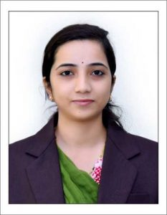 | Name of Faculty:  Sneha. D.KHARBADE  Assistant Professor  Department of Science & Humanities
1. | Name in Full | Ms. Sneha Dharmraj Kharbade
2. | Mother’s Name | Sharda Kharbade
3. | Father’s Name | Dharmraj Kharbade
4. | Postal Address in Full | C/O Bhushan Jalamkar Gaglani Nagar Wadali Naka Amravati
5. | Permanent Address | C/O Bhushan Jalamkar Gaglani Nagar Wadali Naka Amravati
6. | E-mail Address | Snehakharbade18@gmail.com
7. | Designation | Assistant Professor
8. | Department | Science and Humanities
9. | Date of Joining | 13 Jul 2015
10. | Total experience at Sipna COET | 3.5
11. | Total Teaching/Professional Experience | Industrial Experience | Nil
 |  | Teaching Experience | 5.5 years
12. | Academic Qualification | M.Sc.(Physics), B.Ed
13. | RESEARCH PUBLICATIONS:  No. of Papers published in Journals | National  International | 01
 | No. of Papers presented in  Conferences /seminars | National  International
14. | No. of Workshop /STTP/CEP/Training Programs Organized:
15. | No. of Workshop /STTP/CEP/Training Programs Attended: 03/02/0/02
16. | Membership of Professional Bodies/Societies: NIL
17. | Any Other Information: (in brief)  1. NPTEL Course on Semiconductor optoelectronics.

