 | 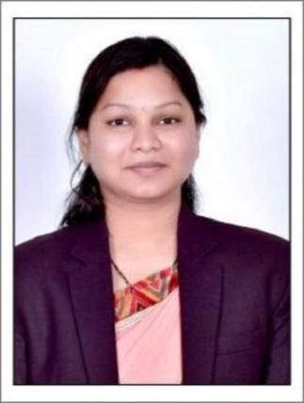 | Name of Faculty:  Mrs. Radhika. G. Kela  Assistant Professor  Department of Science & Humanities
1. | Name in Full | Mrs. Radhika Govinda Kela
2. | Mother’s Name | Mrs. Nisha Agrawal
3. | Father’s Name | Mr. Subhash Agrawal
4. | Postal Address in Full | ‘Govinda’, B-2, Amber Palace, Camp road, Besides Court, Amravati
5. | Permanent Address | ‘Govinda’, B-2, Amber Palace, Camp road, Besides Court, Amravati
6. | E-mail Address | radhikasagrawal@gmail.com
7. | Designation | Assistant Professor
8. | Department | Science & Humanities
9. | Date of Joining | 16 Jun 2016
10. | Total experience at Sipna COET | 3 Years
11. | Total Teaching/Professional Experience | Industrial Experience | 3 Year(s)
 |  | Teaching Experience | 3 Year(s)
12. | Academic Qualification | M.B.A (Marketing/Finance)
13. | RESEARCH PUBLICATIONS:  No. of Papers published in Journals | National  International | -  -
 | No. of Papers presented in  Conferences /seminars | National  International | -  -
14. | No. of Workshop /STTP/CEP/Training Programs Organized: -/-/-/-
15. | No. of Workshop /STTP/CEP/Training Programs Attended: 3/0/0/3
16. | Membership of Professional Bodies/Societies: NIL
17. | Any Other Information: (in brief)  - NPTEL Certification Course : Technical English for Engineers ( Aug - Sept 2018)  - Received ‘Associate of the Month Award’ in Cognizant Technology Solutions.

