 | Photo  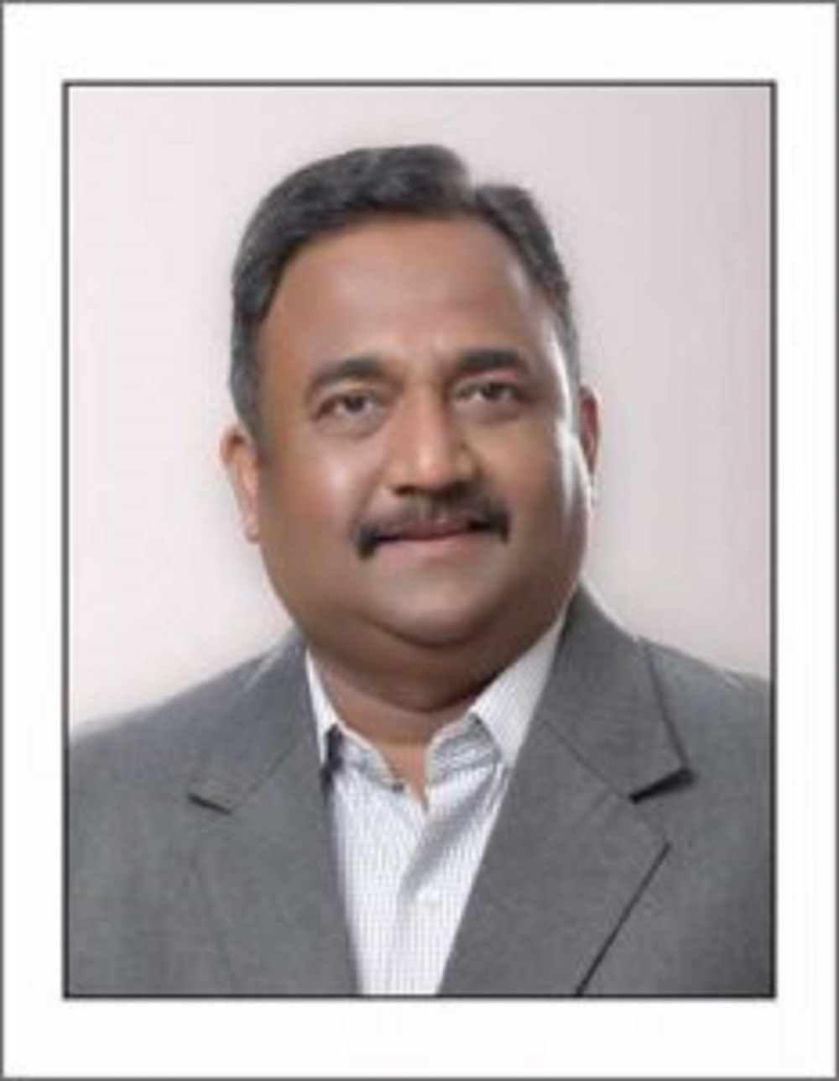 | Name of Faculty:  Dr. nitin v. shirbhate  Head and Associated Professor  Science and Humanities Department.
1. | Name in Full | Dr. Nitin V. Shirbhate
2. | Mother’s Name | Mrs. Ratnamala V. Shirbhate
3. | Father’s Name | Mr. Vishnupant M. Shirbhate
4. | Postal Address in Full | Patel Nagar, Sai Nagar, Amravati.
5. | Permanent Address | Patel Nagar, Sai Nagar, Amravati.
6. | E-mail Address | nvshirbhate@rediffmail.com
7. | Designation | Head and Associated Professor
8. | Department | Science and Humanities Department.
9. | Date of Joining | 20/02/2001
10. | Total experience at Sipna COET | 18.6 Yrs.
11. | Total Teaching/Professional Experience | Industrial Experience | 06 Months
 |  | Teaching Experience | 19 Year(s)
12. | Academic Qualification | Ph.D., M.Sc.(Physics), M. Phil, ADCSSA
13. | RESEARCH PUBLICATIONS:  No. of Papers published in Journals | National  International | 01  04
 | No. of Papers presented in  Conferences /seminars | National  International | 08  01
14. | No. of Workshop /STTP/CEP/Training Programs Organized: Nil
15. | No. of Workshop /STTP/CEP/Training Programs Attended: 21
16. | Membership of Professional Bodies/Societies: 03  - ISTE  - IETE  - IAPT
17. | Any Other Information: (in brief)  - NPTL two courses completed and one is in process.  - Three-week UGC sponsored Refresher Course conducted by SGBAU Amravati.

