 | 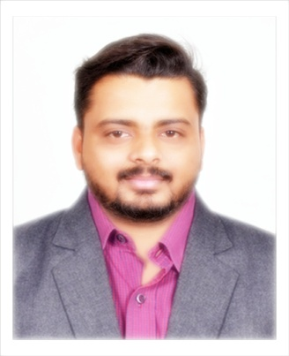 | Name of Faculty:  Mangesh. V. DAMBALE  Assistant Professor  Department of Science & Humanities
1. | Name in Full | Mangesh Vinodrao Dambale
2. | Mother’s Name | Mrs. Mangala Dambale
3. | Father’s Name | Mr. Vinod Dambale
4. | Postal Address in Full | 15, Hari Om Colony Camp, Amravati. 444602
5. | Permanent Address | 15, Hari Om Colony Camp, Amravati. 444602
6. | E-mail Address | Mangeshdambale555@gmail.com
7. | Designation | Assistant Professor
8. | Department | Science & Humanities
9. | Date of Joining | 01 Jul 2017
10. | Total experience at Sipna COET | 2 years
11. | Total Teaching/Professional Experience | Industrial Experience | 03 Year(s)
 |  | Teaching Experience | 02 Year(s)
12. | Academic Qualification | MBA (HR), BBA.
13. | RESEARCH PUBLICATIONS:  No. of Papers published in Journals | National  International | 0  0
 | No. of Papers presented in  Conferences /seminars | National  International | 0  0
14. | No. of Workshop /STTP/CEP/Training Programs Organized: 0
15. | No. of Workshop /STTP/CEP/Training Programs Attended: 2
16. | Membership of Professional Bodies/Societies: Nil
17. | Any Other Information: (in brief)  1.NPTEL Certification Course : Management of Field Sales ( Jan- Feb 2019)

