 | 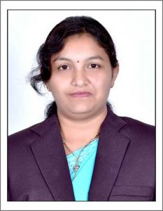 | Name of Faculty:  ms. Manisha. R. JADHAO  Assistant Professor  Department of Science & Humanities
1. | Name in Full | Ms. Manisha Ramrao Jadhao
2. | Mother’s Name | Mrs. Pratibha Jadhao
3. | Father’s Name | Mr. Ramrao Jadhao
4. | Postal Address in Full | C/o Shri S.R. Deshmukh  Bhavna Colony, Ekvira Nagar, Amravati,444607
5. | Permanent Address | C/o Shri S.R. Deshmukh  Bhavna Colony, Ekvira Nagar, Amravati, 444607
6. | E-mail Address | manisha_jadhao2011@rediffmail.com
7. | Designation | Assistant Professor
8. | Department | Science & Humanities
9. | Date of Joining | 01 Jun 2007
10. | Total experience at Sipna COET | 12 Years
11. | Total Teaching/Professional Experience | Industrial Experience | 0 Year(s)
 |  | Teaching Experience | 12 Year(s)
12. | Academic Qualification | M.Sc.(Chemistry), B.Ed, PGDIT
13. | RESEARCH PUBLICATIONS:  No. of Papers published in Journals | National  International | 0  1
 | No. of Papers presented in  Conferences /seminars | National  International | 0  0
14. | No. of Workshop /STTP/CEP/Training Programs Organized: - Nil
15. | No. of Workshop /STTP/CEP/Training Programs Attended: 02/01/0/03
16. | Membership of Professional Bodies/Societies:  1.Indian Society for Technical Education (LM-13301)
17. | Any Other Information: (in brief)  - NPTEL certification courses – 02  - Faculty Development Programme - 04

