 | 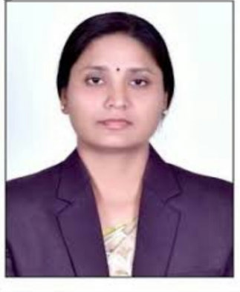 | Name of Faculty:  Dr. smita. v. tambakhe  Assistant Professor  Department of Science & Humanities
1. | Name in Full | Dr. Smita Vasantrao Tambakhe
2. | Mother’s Name | Mrs. Vimala Tambakhe
3. | Father’s Name | Mr. Vasantrao Tambakhe
4. | Postal Address in Full | C/O N.V.Shirbhate, Patel Nagar-2, Sainagar, Amravati.
5. | Permanent Address | Patel Nagar-2, Sainagar, Amravati.
6. | E-mail Address | smitatambakhe@gmail.com
7. | Designation | Assistant Professor
8. | Department | Science & Humanities
9. | Date of Joining | 21 Aug 2006
10. | Total experience at Sipna COET | 13 years
11. | Total Teaching/Professional Experience | Industrial Experience | 0 year(s)
 |  | Teaching Experience | 13 years
12. | Academic Qualification | Ph.D., M.Phil.,M.Sc.(Chemistry), B.Ed, ,
13. | RESEARCH PUBLICATIONS:  No. of Papers published in Journals | National  International | 01  09
 | No. of Papers presented in  Conferences /seminars | National  International | 10  02
14. | No. of Workshop /STTP/CEP/Training Programs Organized: Nil
15. | No. of Workshop /STTP/CEP/Training Programs Attended: 4/5/0/5
16. | Membership of Professional Bodies/Societies:  1.AUCTA (LM-195)  2.ISTE (LM-127394)
17. | Any Other Information: (in brief)  1. MS-CIT (2002)  2. NPTEL Online certification in Analytical Chemistry through IIT, Kharagpur (2018).  3. Two Annual Refresher Programme in Teaching (2019)  4. Three week UGC-Sponsored Refresher course conducted by SGBAU, Amravati (2009).

