 | 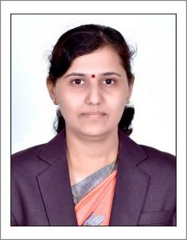 | Name of Faculty:  DR. Soniya. M. BORIKAR  Assistant Professor  Department of Science & Humanities
1. | Name in Full | Dr. Soniya Madhav Borikar
2. | Mother’s Name | Mrs. Minakshi Borikar
3. | Father’s Name | Mr. Madhavrao Borikar
4. | Postal Address in Full | R-10, Eknathpuram, Amravati
5. | Permanent Address | R-10, Eknathpuram, Amravati
6. | E-mail Address | soniyanishant@gmail.com
7. | Designation | Assistant Professor
8. | Department | Science & Humanities
9. | Date of Joining | 01 Aug 2010
10. | Total experience at Sipna COET | 9 Years
11. | Total Teaching/Professional Experience | Industrial Experience | - Year(s)
 |  | Teaching Experience | 15 Year(s)
12. | Academic Qualification | Ph.D. M.Phil. M.Sc.(Mathematics) B.Ed.
13. | RESEARCH PUBLICATIONS:  No. of Papers published in Journals | National  International | - 06
 | No. of Papers presented in  Conferences /seminars | National  International | - 03
14. | No. of Workshop /STTP/CEP/Training Programs Organized: -
15. | No. of Workshop /STTP/CEP/Training Programs Attended: 5/5/0/9
16. | Membership of Professional Bodies/Societies:  1. Indian Society for Technical Education (life membership)
17. | Any Other Information: (in brief)  1. Attended ‘The Culture of India & Japan’ international presentation program at Japan.  2. NPTEL Certification Course i) Ordinary & Partial D.E. & its applications ii) Transform Calculus & its applications in D.E. (12 weeks each)

