 | 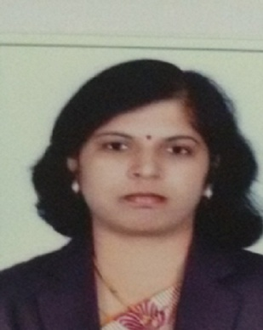 | Name of Faculty:  Dr. Pallavi. s. deshpande  Assistant Professor  Department of Science & Humanities
1. | Name in Full | Dr. Pallavi Shirish Deshpande
2. | Mother’s Name | Mrs. Snehal Chikhalikar
3. | Father’s Name | Mr. Suresh Chikhalikar
4. | Postal Address in Full | G1 Ekwira Apartment,Pundlikbaba Colony,Old bypass,Amravati
5. | Permanent Address | G1 Ekwira Apartment,Pundlikbaba Colony,Old bypass,Amravati
6. | E-mail Address | pallavishirish@gmail.com
7. | Designation | Assistant Professor
8. | Department | Science and Humanities
9. | Date of Joining | 27 Jul 2011
10. | Total experience at Sipna COET | 8 Years
11. | Total Teaching/Professional Experience | Industrial Experience | 0 Year(s)
 |  | Teaching Experience | 14 Year(s)
12. | Academic Qualification | Ph.D., M.Sc.(Physics)
13. | RESEARCH PUBLICATIONS:  No. of Papers published in Journals | National  International | 09
 | No. of Papers presented in  Conferences /seminars | National  International | 05
14. | No. of Workshop /STTP/CEP/Training Programs Organized:
15. | No. of Workshop /STTP/CEP/Training Programs Attended: 04/05/0/05
16. | Membership of Professional Bodies/Societies:  1.Indian Society for Technical Education (Life Membership)
17. | Any Other Information: (in brief)  1.NPTEL Courses - 02  2. Best Poster Presentation Award in Material Science at 91st Session of Indian Science Congress, Chandigarh (3-7 Jan.2004) by the hands of Dr. Abdul Kalam.

