 | 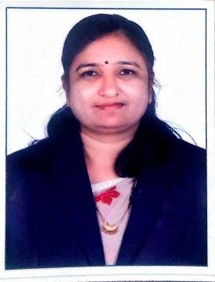 | Name of Faculty:  Dr. nanda. d. sahu  Assistant Professor  Department of Science and Humanities
1. | Name in Full | Dr. Nanda Dalchandji Sahu
2. | Mother’s Name | Mrs. Kamla Sahu
3. | Father’s Name | Mr. Dalchand Sahu
4. | Postal Address in Full | C/o. P V. Paralikar 98 A Om niwas Chhangani nagar Amravati 444605
5. | Permanent Address | C/o. P V. Paralikar 98 A Om niwas Chhangani nagar Amravati 444605
6. | E-mail Address | nandasahu31@gmail.com
7. | Designation | Assistant Professor
8. | Department | Science and Humanities
9. | Date of Joining | 17 Jul 2007
10. | Total experience at Sipna COET | 12 Years
11. | Total Teaching/Professional Experience | Industrial Experience | 0 Year(s)
 |  | Teaching Experience | 14 Year(s)
12. | Academic Qualification | Ph. D, M.Phil. M.Sc.(Mathematics), B.Ed.
13. | RESEARCH PUBLICATIONS:  No. of Papers published in Journals | National  International | 00  07
 | No. of Papers presented in  Conferences /seminars | National  International | 01  00
14. | No. of Workshop /STTP/CEP/Training Programs Organized:00
15. | No. of Workshop /STTP/CEP/Training Programs Attended: 04/05/04
16. | Membership of Professional Bodies/Societies:  1 ISTE (LM-102830)
17. | Any Other Information: (in brief)  - NPTEL Online certification Courses through IIT, Kharagpur and Roorkee – 02  - Faculty Development Programme - 06

