 | 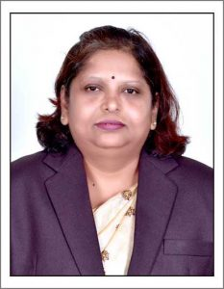 | Name of Faculty:  Dr. Mohini. R. UGALE  Associate Professor  Department of Science & Humanities
1. | Name in Full | Dr. Mohini Ramrao Ugale
2. | Mother’s Name | Mrs. Shshikala Ugale
3. | Father’s Name | Mr. Ramrao Ugale
4. | Postal Address in Full | Anant chowk , Budhwara Road , Amravati
5. | Permanent Address | C/O C. B. Kale ,Anant chowk , Budhwara Road ,Amravati
6. | E-mail Address | Mohini_261@rediffmail.com
7. | Designation | Associate Professor
8. | Department | Science & Humanities
9. | Date of Joining | 16 Aug 2002
10. | Total experience at Sipna COET | 17 Years
11. | Total Teaching/Professional Experience | Industrial Experience | 0 Year(s)
 |  | Teaching Experience | 17 Year(s)
12. | Academic Qualification | Ph.D., M.Phil., M.Sc. (Mathematics), B.Ed. P.G.D.C.S
13. | RESEARCH PUBLICATIONS:  No. of Papers published in Journals | National  International | 2  18
 | No. of Papers presented in  Conferences /seminars | National  International | 12  11
14. | No. of Workshop /STTP/CEP/Training Programs Organized: Nil
15. | No. of Workshop /STTP/CEP/Training Programs Attended: 14/5/0 / 6
16. | Membership of Professional Bodies/Societies:  1.ISTE Member
17. | Any Other Information: (in brief)  1.BOS Member SGBAU  2.Two NPTEL ONLINE COURSES

