 | 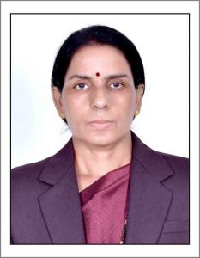 | Name of Faculty:  Dr. Kiran. V. PAWAR  Assistant Professor  Department of Science and Humanities
1. | Name in Full | Dr. Kiran Vishwasrao Pawar
2. | Mother’s Name | Mrs. Chabbutai Pawar
3. | Father’s Name | Mr. Vishwasrao Pawar
4. | Postal Address in Full | C/O Prof. Sunil Deshmukh Om Sai Vihar Rahatgaon Rd, Amravati.
5. | Permanent Address | C/O Prof. Sunil Deshmukh Om Sai Vihar Rahatgaon Rd, Amravati.
6. | E-mail Address | Dr.kvpawar@gmail.com
7. | Designation | Assistant Professor
8. | Department | Science & Humanities
9. | Date of Joining | 14 Jun 2010
10. | Total experience at Sipna COET | 9 years
11. | Total Teaching/Professional Experience | Industrial Experience | 0 Years(s)
 |  | Teaching Experience | 10 Year(s)
12. | Academic Qualification | Ph.D.,M.Sc.(Zoology),M.Sc.(Environmental Ecology) B.Ed
13. | RESEARCH PUBLICATIONS:  No. of Papers published in Journals | National  International | 5  3
 | No. of Papers presented in  Conferences /seminars | National  International | 1
14. | No. of Workshop /STTP/CEP/Training Programs Organized:
15. | No. of Workshop /STTP/CEP/Training Programs Attended: 2/2/2
16. | Membership of Professional Bodies/Societies: NIL
17. | Any Other Information: (in brief)  - NPTEL online Certification of IITM  - President of Sipna Nature Club (Gov. Reg. No. E- 874/2015/AMT.)

