 | 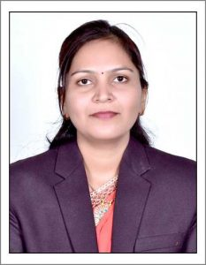 | Name of Faculty:  Dr. Gayatri. B. tayade  Assistant Professor  Department of Science & Humanities
1. | Name in Full | Dr. Gayatri Bharat Tayade
2. | Mother’s Name | Mrs. Sheela Tayade
3. | Father’s Name | Mr. Bharat Tayade
4. | Postal Address in Full | C/O A.S.Bansod, Saraf Layout, Kaloti Nagar road near Dastur nagar square, Amravati.
5. | Permanent Address | C/O A.S.Bansod ,Saraf Layout ,Kaloti Nagar road near Dastur nagar square,Amravati.
6. | E-mail Address | gayatri.tayade@gmail.com
7. | Designation | Assistant Professor
8. | Department | Science and Humanities
9. | Date of Joining | 04 May 2009
10. | Total experience at Sipna COET | 10 Years
11. | Total Teaching/Professional Experience | Industrial Experience | NIL
 |  | Teaching Experience | 10 Year(s)
12. | Academic Qualification | Ph.D.,M.Sc.(Mathematics)
13. | RESEARCH PUBLICATIONS:  No. of Papers published in Journals | National  International | 10
 | No. of Papers presented in  Conferences /seminars | National  International | 0
14. | No. of Workshop /STTP/CEP/Training Programs Organized: NIL
15. | No. of Workshop /STTP/CEP/Training Programs Attended: 05/02/0/03
16. | Membership of Professional Bodies/Societies:  1.Membre of ISTE(LM 114994)
17. | Any Other Information: (in brief)  1.Two NPTEL online course  2.Faculty Development Programmes : 03

