 | 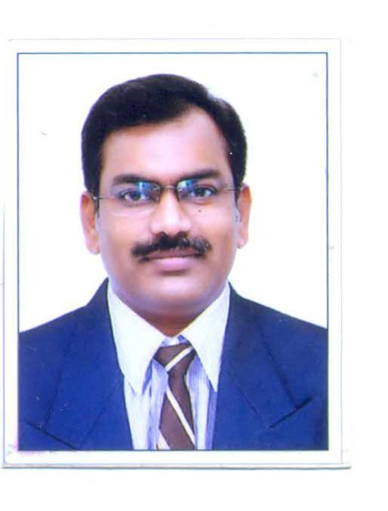 | Name of Faculty:  Dr. AJAY P. THAKARE  Professor - Electronics and Telecommunication Engineering
1. | Name in Full | DR. AJAY PURUSHOTTAMRAO THAKARE
2. | Mother’s Name | MALATIBAI THAKARE
3. | Father’s Name | PURUSHOTTAM Z. THAKARE
4. | Postal Address in Full | 15, SANJEEVANI COLONY, NEAR CONGRESS- NAGAR, AMRAVATI-444602
5. | Permanent Address | 15, SANJEEVANI COLONY, NEAR CONGRESS -NAGAR, AMRAVATI-444602
6. | E-mail Address | apthakare40@rediffmail.com
7. | Designation | Professor and Degree Program Coordinator (UG)
8. | Department | Electronics and Telecommunication
9. | Date of Joining | 29/04/2006
10. | Total experience at Sipna COET | 13 Years and 4 Months
11. | Total Teaching/Professional Experience | Industrial Experience | Year(s): Nil
 |  | Teaching Experience | Year(s): 29 Years  (3$1/2$ Years in Foreign University )
12. | Academic Qualification | B.E.,M.E.,Ph.D.
13. | RESEARCH PUBLICATIONS:  No. of Papers published in Journals | National  International | 12  28
 | No. of Papers presented in  Conferences /seminars | National  International | 06  03
14. | No. of Workshop /STTP/CEP/Training Programs Organized: 07/06/02/08
15. | No. of Workshop /STTP/CEP/Training Programs Attended: 25/13/03/04
16. | Membership of Professional Bodies/Societies:  1.F-121223, Fellow IETE  2.F-114025, Fellow IE  3.LM-12293, Member ISTE
17. | Any Other Information: (in brief)  - ACADEMIC SERVICES  - Member of Board of Studies in Electronics and Telecommunication Engineering (12/2019), SGB Amravati University, Amravati.  - Member of Model Curriculum Committee, constituted by hon’ble Vice Chancellor, SGB Amravati University, Amravati (2019)  - Ph.D. supervisor in Electronics Engineering 95/22/2019, SGB Amravati University, Amravati.  - Presently, Degree Program Coordinator (DPC) for the UG Programs.  - Presently, Governing Council member (Elected), IETE New Delhi.  - Presently, Mentor East Zone, IETE, New Delhi.  - Worked as Head of Deptt. for 12 Years in Deptt of EXTC of Sipna COET, Amravati.  - As Chairman, IETE Amravati Centre (2014-16).  - As Secretary, IETE Amravati Centre (2004-10).  - Worked in Foreign University at Defense Engineering College at Debre Zeit, Ethiopia (East Africa)- (1999-2002)  - As Secretary Academic Council, DEC, Debre Zeit (2000-01).  - As Section Head, Comm. Tech. Dept. in EED, DEC, Debre Zeit (2001-02).  - Visited 8 countries till date for Educational Purpose.  - Presented Paper in International Conference “Tencon 2009” held at Singapore.  - Worked as Session Chair for the International Conference in Tokyo, Japan in Nov 2017.  - Recently Invited as Speaker to deliver talk at the International Conference being held in Oludeniz, Turkey on 22nd October 2019.  - AWARDS & RECOGNITIONS  - IETE, New Delhi “Brig. M. L. Anand” National Award ( Sept 2015).  - Best Centre award for the IETE Amravati Centre, as Chairman Amravati Centre (2016).

