 | 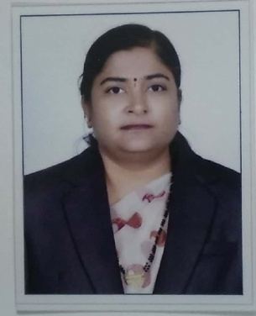 | Name of Faculty:  Mrs. Arti. J. Pande  Assistant Professor  Department of Science & Humanities
1. | Name in Full | Mrs. Arti Jagdish Pande
2. | Mother’s Name | Mrs. Shakuntala Varudkar
3. | Father’s Name | Mr. Vasudevrao Varudkar
4. | Postal Address in Full | Shriram Apt, Jairam nagar, Amravati
5. | Permanent Address | Shriram Apt, Jairam nagar, Amravati
6. | E-mail Address | aj_pande@rediffmail.com
7. | Designation | Assistant Professor
8. | Department | Science & Humanities
9. | Date of Joining | 02 Aug 1999
10. | Total experience at Sipna COET | 20 YEARS
11. | Total Teaching/Professional Experience | Industrial Experience | NIL
 |  | Teaching Experience | 20.6 Years
12. | Academic Qualification | M.Sc.(Mathmatics), M.Phil. B.Ed.
13. | RESEARCH PUBLICATIONS:  No. of Papers published in Journals | National  International | NIL
 | No. of Papers presented in  Conferences /seminars | National  International | NIL
14. | No. of Workshop /STTP/CEP/Training Programs Organized: One orientation program on  PUSH Act, Sipna COET,Amt
15. | No. of Workshop /STTP/CEP/Training Programs Attended: 5/5/nil/4
16. | Membership of Professional Bodies/Societies:  1. MMS  2. ISTE  3. IMS
17. | Any Other Information:  1. One Refresher course at SGBAU,Amravati  2. Two NPTEL Online Courses  3. Govt Certified professional course on ISO Internal Auditor  4. Four FDP  5. Three National & one International Conferences

