A Dissertation Report on

<DISSERTATION TITLE>

Submitted for partial fulfillment of requirement for the degree of

MASTER OF ENGINEERING

in

<NAME OF BRANCH>

by

<NAME OF STUDENT>

Under the guidance of

<NAME OF GUIDE>

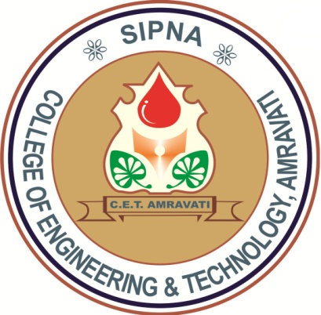

<Name of Department>

Sipna College of Engineering & Technology, Amravati
(NAAC Accredited with Grade ‘A’)

Sant Gadge Baba Amravati University, Amravati
2019-2020

