Sipna College of Engineering and Technology, Amravati
Department of Mechanical Engineering

Students placed through Campus Recruitment in Treo Engineering Pvt. Ltd.

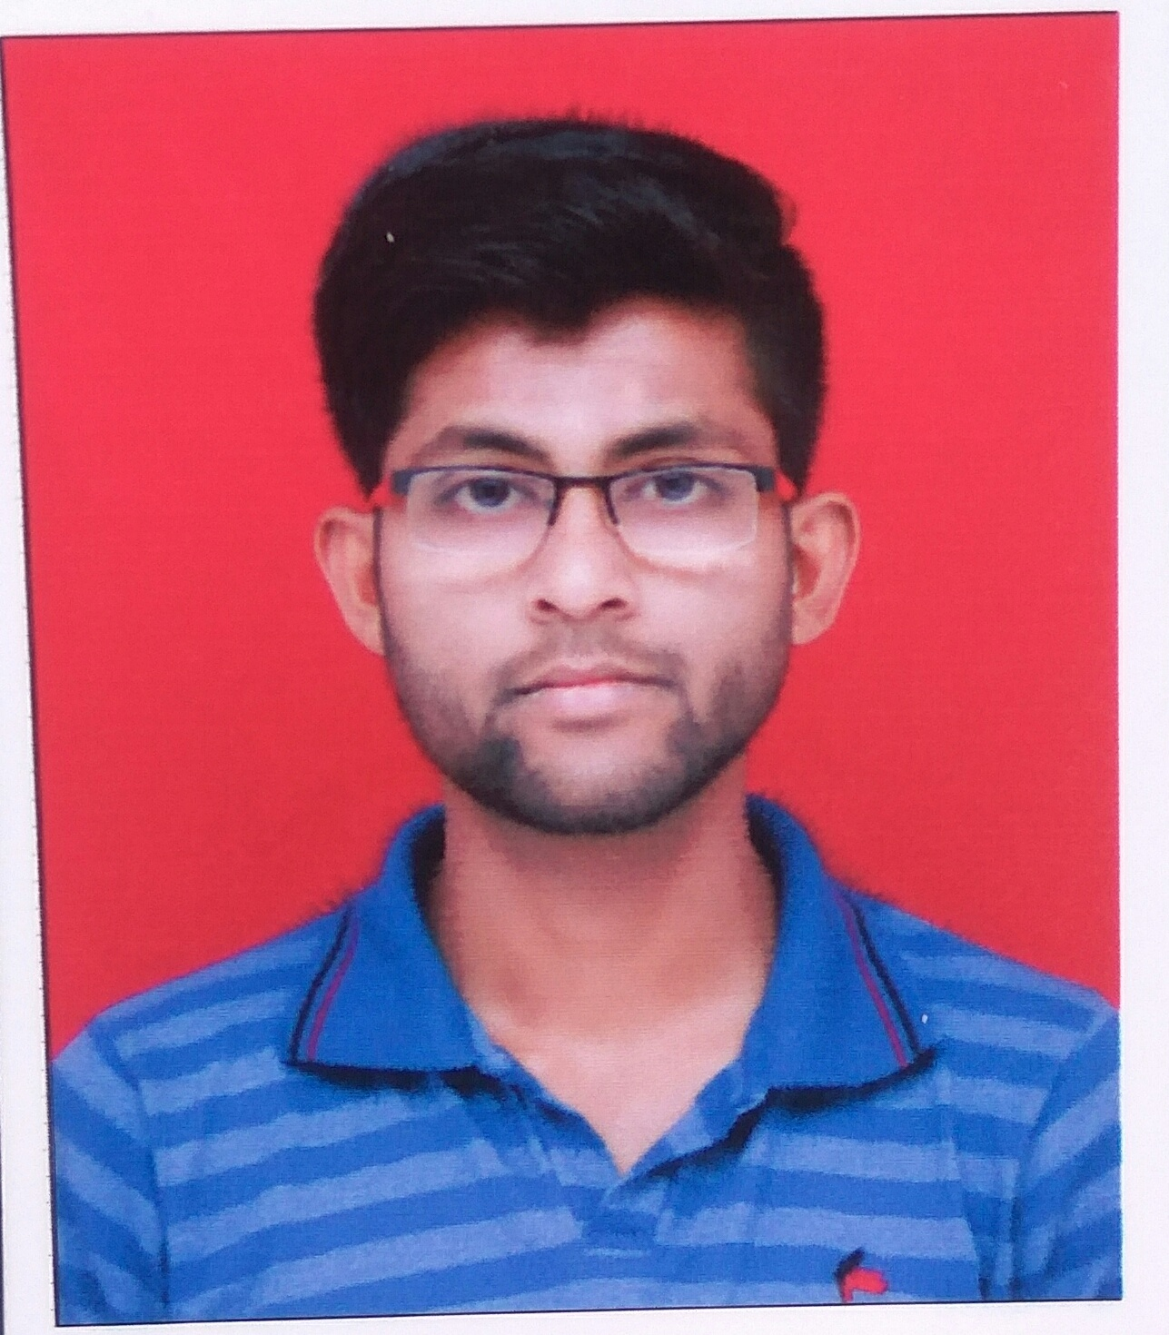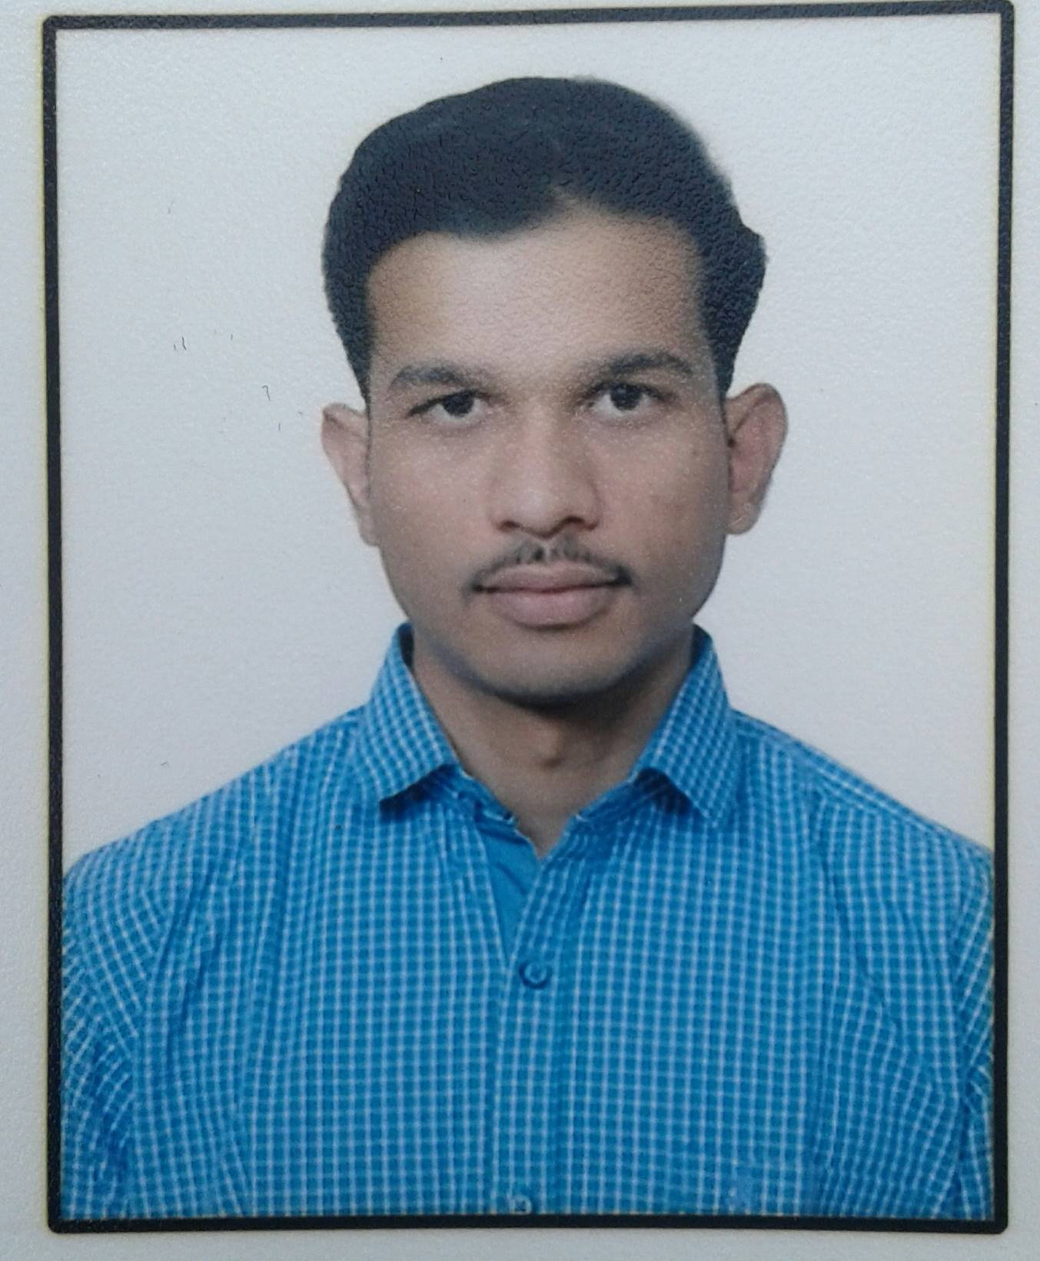

Shubham Mahule Pranay Ukey Ajinkya Harne Pawan Sawai Gaurav Morande

