Sipna College of Engineering and Technology
Department of Electronics and Telecommunication Engineering
Congratulations….!!!!
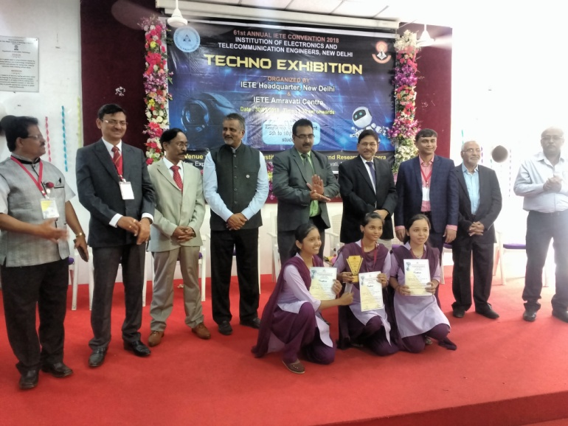
Heartily Congratulations to Ku. Nikita Chopde, Ku. Puja Ugale, KU. Shraddha Chavhan and Ku. Garju Bardeo [Final Year EXTC-B] got Third Prize in Project Competition TECHXELLENCE UG student conference “Smart Engineering For Sustainable Development”, organized by IETE Headquarter, New Delhi & IETE Amravati Center on 30th September 2018 at Prof. Ram Meghe Institute of Technology & Research, Badnera

