DISSERTATION APPROVAL SHEET
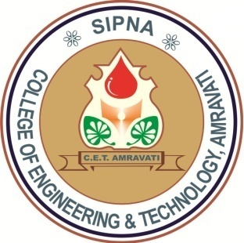
Dissertation Entitled
“<Title of Dissertation>”
by
<Name of Student>
is approved for the degree of
Master of Engineering
in
Computer Science & Engineering
of
Sant Gadge Baba Amravati University, Amravati

Internal Examiner: External Examiner:
Name: Name:
Date: Date:

