A Seminar Report on

Seminar Title

submitted for partial fulfillment of requirement for the degree of

BACHELOR OF ENGINEERING

in

DEPARTMENT

By

NAME OF STUDENT(s)

Under the guidance of

GUIDE NAME

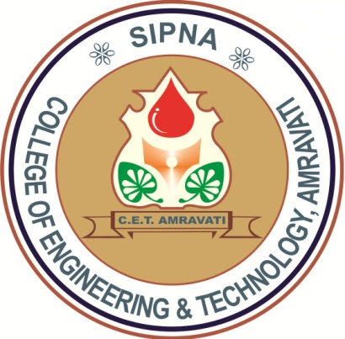

Information Technology

Sipna College of Engineering & Technology,
Amravati.
(An ISO 9001: 2008 Certified)

Sant Gadge Baba Amravati University, Amravati
2018-2019

