DEPARTMENT OF MECHANICAL ENGINEERING
Sipna College of Engineering and Technology, Amravati

Session 2017-18
PROGRAMS OFFERED:
- B.E. Mechanical Engineering (60 Seats)
- Direct Second Year (12 Seats)
- Mechanical Engineering Students Association (MESA)
- Immortal Sipnoids
- MOU with 10 local industries and two industries in Nasik.

ABOUT DEPARTMENT:

The department of mechanical engineering caters to its students with class tutorial and state-of-the-art laboratories.

The department is continuously striving to achieve excellence in education, academic and industry oriented research as well as consultancy work with service to the society.

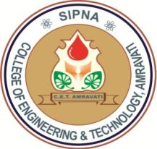

From the Head of Department Desk
Prof. S.S. Ingole

Inside Issues
Events
1 | Wall Magazine
2 | Student Achievements
3 | Student Activity
4 | Staff Achievements
- Umang – 2018
- Yuvanand
- Vidyotan
- Participation in Formula Cart Design Competition 2018 organized by FMAE, Banglore.

EDITORIAL BOARD:-
Prof. B.N.Maldhure
Department of Mechanical Engineering

Wall Magazine Commmittee - MechZing

Objectives

- To provide opportunity to the students for self-expression in written form.
- To develop and cultivate in students the literary taste and study habits.
- To provide training to students for better utilization of their leisure time.
- To develop in students a sense of loyalty towards the institution, pride for its achievements.
- To develop in students right standards of conduct.
- To provide encouragement for and to stimulate worth-while activities.

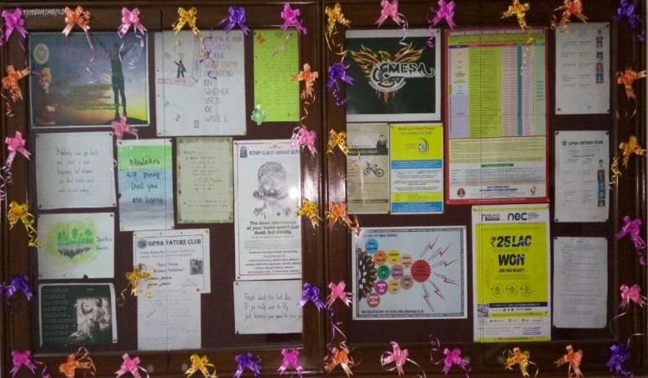
Department Of Mechanical Engineering
Student Achievements
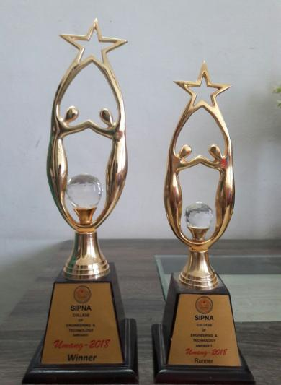
- Tushar Kamble from 2nd year was Winner for Umang 2018 Badminton tournament singles & Mix doubles and Runner up in Men’s doubles.
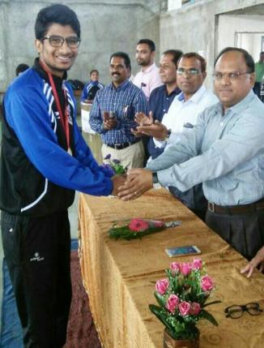
- Pratik Bandabuche from final year was a Winner and got gold medal for SGBAU intercollegiate Fencing Championship 2017-18”
- Also Awarded Third time with colour coat and represented as a Captain for SGBAU Fencing team in all india Interuniversity Champianship.

Department Of Mechanical Engineering
- Students from Final, Third and second year were Winner for Pro-Kabaddi matches “IGNITE 2018” at Mauli College of Engineering, Shegaon.
Students Activity

Guests Lectures

Sr.No. | Name of the Speaker | Topic
1 | Mr. Shubham Somani  (Founder, Indo-Vidarbha Tool Room, Akola) | Design Software Trends industries
2 | Mr. Gyanprakash Verma,  Principal IIPDM,Nagpur | Role of CAD/CAM/CAE in Moulds and Dies making
3 | Mr. Linesh Pandey,  Director, Shreenath Packers MIDC, Amravati | How to become a successful Entrepreneur
4 | Dr. Avinash Mohril,  Principal, Mahila Maha Vidyalaya,Amravati | Azadi Nayi Jung
5 | Mr. Nikhil Kolpyakwar, Business Developemnet Associate, AMZ Automotive, Jaipur | Scope of Automotive Sector

Industrial Visits
Department Of Mechanical Engineering
Sr.No. | Name of the Industry | Number of Students
1 | Jadhao Steel Alloys,Pvt ltd, MIDC, Amravati | 45
2 | Suryalakshmi Cotton Mills, Pvt ltd, Nandgaopeth, Amravati | 53

Participation in Events by Students
Sr.No. | Name of the Event | Organized by | Number of Students | Rank
1 | Formula Cart Design Challenge 2018 | Fraternity of Mechanical & Automotive Engineers, Bangaluru | 20 | Runner up in Skid PAd & Autocross
Staff Achievements

- Faculty members Prof. C.R.Bundele, Prof. A.M.Wankhade & Prof. S.H.Ingle attended Faculty Development Program at Prof. Ram Meghe Institute Technology and Research based on “Rapid Prototyping for Industrial And Medical Applications”

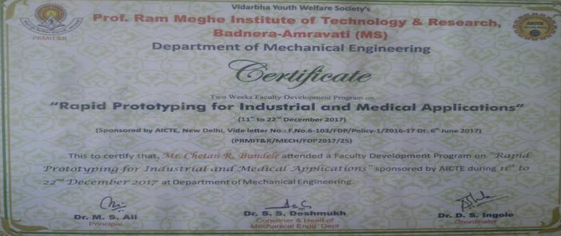

The college of Engineering and technology was establish in 1999 to provide quality professional and technical education to the student of the region and around seeking various under graduate, post graduate engineering courses, management and research programmers. These courses are approved by All India Council for Technical Education, New Delhi and Government of Maharashtra affiliated to SantGadge Baba Amravati University, Amravati. The institute is certified by ISO 9001:2008 certification.
The Institute has accredited by IAO (International Accreditation Organization) for welfare of student to be placed at International level all over World. The institution also has collaboration with College Of Engineering, Pune.

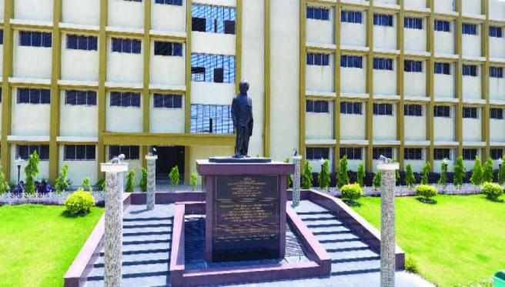

ADDRESS: Website:
In Front of NemaniGodown, Badnera Road, WWW.sipnaengg.ac.in
Amravati, Phone: - 0721-2522341
MAHARASHTRA,444701 0721-2522342

About Institution
Department Of Mechanical Engineering

