Sipna College of Engineering & Technology, Amravati
Department of Computer Science & Engineering
Placed Student Batch 2017 – 18
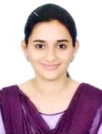
Epic Research Pvt Ltd, Indore
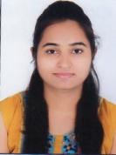
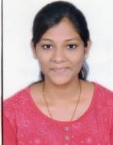

Prachi Joshi TejaswiniBundele AnuradhaYende Pooja Jadhav

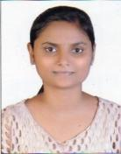
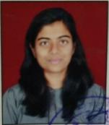
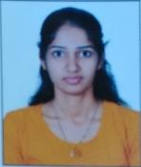

ArtiDhanokar AnkitaJadhav Priyanka Khandezod NishaJaiswal
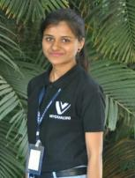

SanyuktaMisar Pankaj Prajapati

Ways 2 Capital Pvt Ltd, Indore
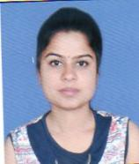
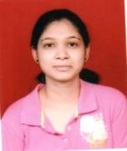

Priyanka Sawai KalyaniWankhade Pooja Rathi Snehagandha Thakur
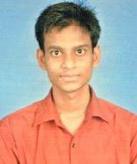
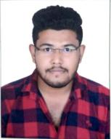

Pratik Nagargoje Darshan Sharma Pratik Mendhe
Amazon Pvt Ltd.
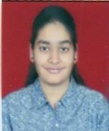
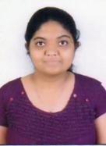

PrajaktaKarale Anjali Pakde SurabhiBhutda Rahul Nimkar

Cinif Technology, Chandigarh
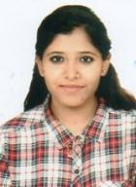

SakshiManwani Bharti Jaiswal ShubhamHirapure

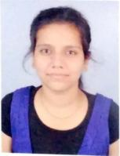
Arete Technology, Nashik
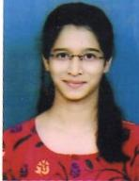

RenukaDeshmukh LavinaHarwani Snehagandha Thakur KalyaniDaurewar

Axiom TechguruPvt Ltd, Nagpur
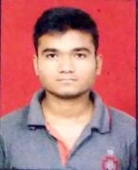

ShekharPunshe Rujuta Tale
PinnaculumInfotech, Amravati
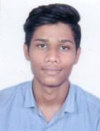
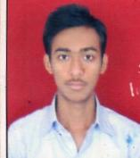

BhushanPardhi Pratik Damke
Cybage Software Pvt Ltd, Pune Universal Education
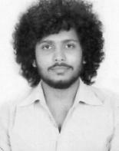

Aditi Marathe YashTelgote

SmartData Enterprises (I) Ltd. Eternus Solutions, Pune
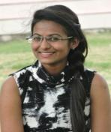
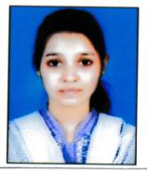
Karan Patokar Riya Anasari ShivaniRathi

iASYS Technology solutions pvt.Ltd Sedna InfoSystems Pvt. Ltd
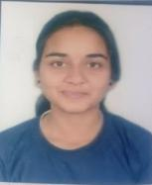
PratikshaDatir Pooja Rathi SurabhiBhutda

Sipna College of Engineering & Technology, Amravati
Department of Computer Science & Engineering
Placed Student Batch 2017 – 18
